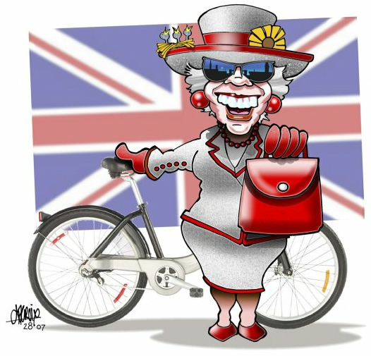
English

Important Topic/Text

Pillow Angel
Hospitalization-Patients’ Charter
Multiple aspects of addiction
Medical Ethics
Quadruple jeopardy
Concierge doctor
Ethics Committee / Ethical questions

Vocabulary

- Disability / Handicap  - Brain damage  - Bedridden = être alité  - Bedsores = escarts  - Hysterectomy  - High dose estrogen  - To stunt growth (Stop growth with a treatment)  - Breast bud removal  - Appendectomy | - Charter of Patients’ Rights  - Charter of Patient’s Rights  - Informed consent  - Invasive procedure  - Advance directives/ Living will  - Person of trust  - Respect/Dignity/Care  - Treatment  - Confidentiality | - Addiction/Addict  - Hooked  - Alcoholism/Binge drinking  - Binge  - Rehabilitation  - Breaking an addiction/a habit  - Different types of addiction | - Medical Ethics  - Professional conduct  - “First do no harm”  - Quadruple jeopardy (= 4 risques que le médecin peut provoquer)  - Mishap/Incident/Adverse event  - Malpractice suit/care  - To be struck off the medical register  - Breach of confidentiality | - Puncture wounds  - Blurred vision  - Slurred speech  - Retainer  - Referral – Specialty referral  - Pro bono (= Free)  - Locum (= medical replacement)  - Cast = plâtre  - Ambulance  - 24 hr access or 24/7 access  - Bedside manner

Vocabulary from exercises p. 11 + p.19 + p.23 + p.29 to 31 + p.45 + p.46

